Outreach Tools for FY25 Budget – Focus on Pro Bono (Updated 5.9.24)

SOCIAL MEDIA - Be active on social media! Tagging individual Councilmembers makes a difference.
Potential tag lines: #dcciviljustice #restoreATJfunding #theInitiativeworks
Consider tagging: DC Council (@councilofdc); Councilmembers (see below); Commission (@DCATJComm); DC Bar Foundation (@DCBarFoundation)
Sample Tweets (remember 280 character limit – or do a thread)
The ATJ Initiative makes pro bono possible. DC Council must restore $31.668M. #DCCivilJustice @chmnmendelson @anitabondsdc @CM_McDuffie @robertwhite_dc @CMCHenderson @brianneknadeau @CMBrookePinto @CMFrumin @CMLewisGeorgeW4 @CMZParker5 @charlesallen @vincegrayward7 @trayonwhite

Twitter Card available HERE
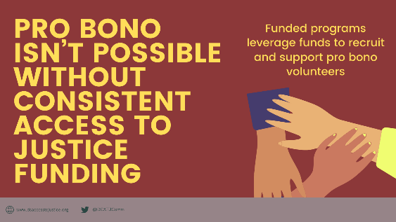

The Access to Justice Initiative works. We urge the Council to restore ATJ funding of $31.668M. @chmnmendelson @anitabondsdc @CM_McDuffie @robertwhite_dc @CMCHenderson @brianneknadeau @CMBrookePinto @CMFrumin @CMLewisGeorgeW4 @CMZParker5 @charlesallen @vincegrayward7 @trayonwhite

Twitter Card available HERE
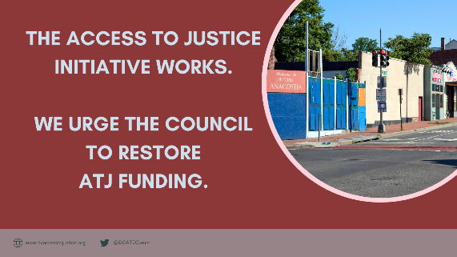

We agree with @DCATJComm that cuts to the Access to Justice Initiative put individual and community stability at risk. #DCCivilJustice

Twitter Card available HERE
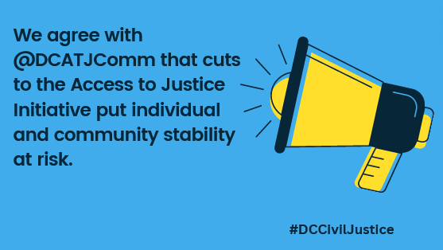

Group Tweet D.C. Council: @chmnmendelson @anitabondsdc @CM_McDuffie @robertwhite_dc @CMCHenderson @brianneknadeau @CMBrookePinto @CMFrumin @CMLewisGeorgeW4 @CMZParker5 @charlesallen @vincegrayward7 @trayonwhite

E-MAIL OUTREACH - Send e-mails to Councilmembers. Individual, personalized e-mails are better than group e-mails, but any contact would be helpful!

Sample E-Mail (from Firm Leadership and/or Pro Bono Counsel)

Councilmember [CM name] or Councilmembers [if group e-mail]:

Our law firm is reaching out to express our concern about the drastic cuts to the Access to Justice Initiative and to ask the Council to restore funding to $31.668M. [If relevant, add that the author is a resident of Ward #.] Our law firm partners with many Initiative-funded organizations. While we are grateful that the Judiciary Committee identified funds to partially restore the program, there is still a $18.9M or 60% gap in funding that we hope the D.C. Council will prioritize filling in the coming weeks.

While we are dedicated to our pro bono commitments, pro bono service could never fill the service gaps that will result from this reduction in support. This cut will undoubtedly diminish our ability to provide pro bono support since we are dependent on an appropriately resourced legal services community to screen potential pro bono cases and support our lawyer volunteers, who’d be reluctant to practice in unfamiliar areas without that help.

These services are crucial for District residents. [Insert case example where a firm attorney represented a DC resident pro bono.]

As you consider the proposed FY25 budget, please keep the Access to Justice Initiative among your highest budget priorities. We support the D.C. Access to Justice Commission’s efforts to restore funding of $31.668M to this vital program.

Sincerely,

[Firm leadership and/or Pro Bono Counsel]

Sample E-Mail (from Pro Bono Attorney, especially if DC resident)

Councilmember [CM name]:

I am reaching out to voice support for restoring funding for the Access to Justice Initiative to the FY24 level of $31.668M. [I am a resident of D.C. and live in Ward [insert #].

As a D.C. [resident/worker] I am proud of the Council’s historic investment in this program. I fully support the Council doing whatever it can to reverse cuts to this program and restore FY24 funding.

As a lawyer who [lives and works] in DC, I want to help my neighbors and so I volunteer with [insert legal services organization] to use my legal background to help people who otherwise wouldn’t have access to a lawyer. I would not be able to volunteer without the support of the legal services lawyers. The work they do to find a good case for me, train me on the law, and mentor me as I have questions throughout the case is essential. I’m worried that if there are these drastic cuts to legal services stay in place, they won’t be able to help and that will make it hard for me to take on pro bono cases.

[Insert case example where you represented a DC resident pro bono.]

I thank the D.C. Council for its longstanding support of the Access to Justice Initiative and hope that you will restore FY24 funding of $31.668M so that we can continue to meet the needs of our District neighbors.

Sincerely,

[Name and Address]

D.C. Councilmember and Committee Rosters available in PDF and MS Word

