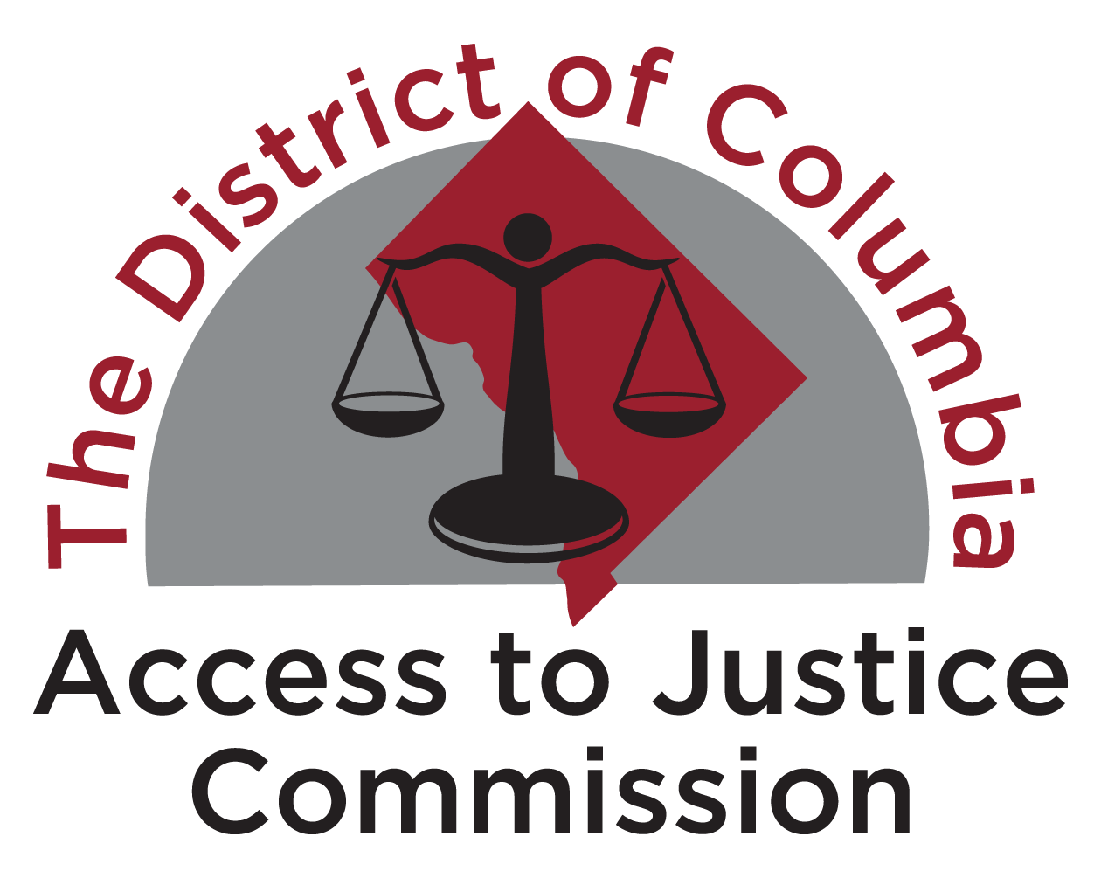
Outreach Tools for FY25 Budget (Updated 5.9.24)
Potential tag lines: #dcciviljustice #restoreATJfunding #theInitiativeworks
Consider tagging: DC Council (@councilofdc); Councilmembers (see below); Commission (@DCATJComm); DC Bar Foundation (@DCBarFoundation)

THANK YOU FOR COMMITTEE SUPPORT (TARGET 5/9, 5/10)

Sample Tweets (remember 280 character limit – or do a thread)
We thank the Judiciary, Business/Econ Development, & Health Comms for partially restoring ATJ Initiative funds. We ask the Council to restore funding to $31.668M. @CMBrookePinto @CM_McDuffie @CMCHenderson @charlesallen @anitabondsdc @brianneknadeau @CMZParker5 @vincegrayward7
Sample E-Mails
Judiciary Committee
TO: bpinto@dccouncil.gov; callen@dccouncil.gov; abonds@dccouncil.gov; vgray@dccouncil.gov; chenderson@dccouncil.gov
CC: emarolf@dccouncil.gov; erodriguezlabrada@dccouncil.gov; GHulick@dccouncil.gov; jhudson@dccouncil.gov; mshaffer@dccouncil.gov; grogoff@dccouncil.gov; lgroft@dccouncil.gov; kmitchell@dccouncil.gov; anunes@dccouncil.gov; sbunn@dccouncil.gov; tnorflis@dccouncil.us
Chair Pinto, Members of the Judiciary & Public Safety Committee, and Committee Staff:
Thank you for your leadership in identifying funds to partially restore the Access to Justice Initiative. We are grateful for your commitment to and partnership in this critical work. Thank you also for including language in the committee report urging your colleagues to work at the full Council level to restore funding to level FY24 funding of $31.668M.
Thank you, again.
[Signed]

Business & Economic Development Committee
TO: kmcduffie@dccouncil.gov; callen@dccouncil.gov; abonds@dccouncil.gov; bpinto@dccouncil.gov; vgray@dccouncil.gov
CC: jkim@dccouncil.gov; dparks@dccouncil.gov; dcrawford@dccouncil.gov; jhudson@dccouncil.gov; ghulick@dccouncil.gov; lgroft@dccouncil.gov; kmitchell@dccouncil.gov; anunes@dccouncil.gov; sbunn@dccouncil.gov; tnorflis@dccouncil.us
Chair McDuffie, Members of the Business & Economic Development Committee, and Committee Staff:
Thank you for identifying funds to transfer to the Judiciary Committee to assist in partially restoring Access to Justice Initiative funding. We are grateful to you for recognizing that the Initiative promotes the District’s stability and economic health. We hope that you will work with your colleagues at the full Council to restore level FY24 funding of $31.668M.
Thank you, again.
[Signed]

Health Committee
TO: chenderson@dccouncil.gov; callen@dccouncil.gov; vgray@dccouncil.gov; BNadeau@dccouncil.gov; zparker@dccouncil.gov
CC: obalkus@dccouncil.gov; mshaffer@dccouncil.gov; grogoff@dccouncil.gov; nrivero@dccouncil.gov; dmeni@dccouncil.gov; rroberts@dccouncil.gov; kwiley@dccouncil.gov; kmitchell@dccouncil.gov; anunes@dccouncil.gov; sbunn@dccouncil.gov; tnorflis@dccouncil.us
Chair Henderson, Members of the Health Committee, and Committee Staff:
Thank you for identifying funds to transfer to the Judiciary Committee to assist in partially restoring Access to Justice Initiative funding. We are grateful to you for recognizing how the Initiative uniquely promotes the health and well-being of District residents, particularly in partnership with numerous health systems. We hope that you will work with your colleagues at the full Council to restore level FY24 funding of $31.668M.
Thank you, again.
[Signed]

RESTORE FUNDING AT FULL COUNCIL (TARGET 5/13)

Sample Tweets (remember 280 character limit – or do a thread)
FY25 cuts will deny DC residents meaningful access to justice. Restore $31.668M. @chmnmendelson @anitabondsdc @CM_McDuffie @robertwhite_dc @CMCHenderson @brianneknadeau @CMBrookePinto @CMFrumin @CMLewisGeorgeW4 @CMZParker5 @charlesallen @vincegrayward7 @trayonwhite

Twitter Card available HERE
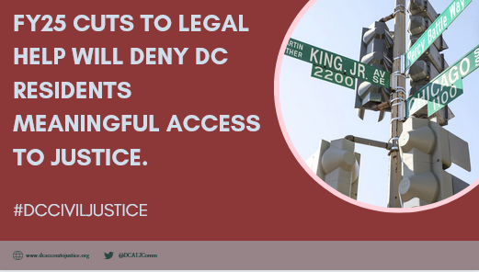

The Access to Justice Initiative works. We urge the Council to prioritize ATJ funding. @chmnmendelson @anitabondsdc @CM_McDuffie @robertwhite_dc @CMCHenderson @brianneknadeau @CMBrookePinto @CMFrumin @CMLewisGeorgeW4 @CMZParker5 @charlesallen @vincegrayward7 @trayonwhite

Twitter Card available HERE
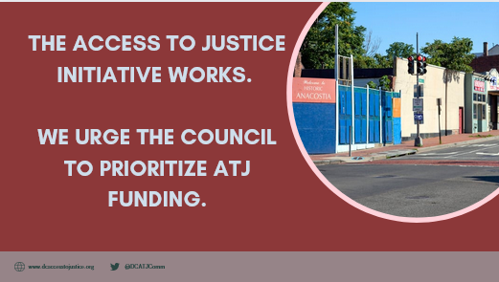

We agree with @DCATJComm that cuts to the Access to Justice Initiative put individual and community stability at risk. #DCCivilJustice

Twitter Card available HERE
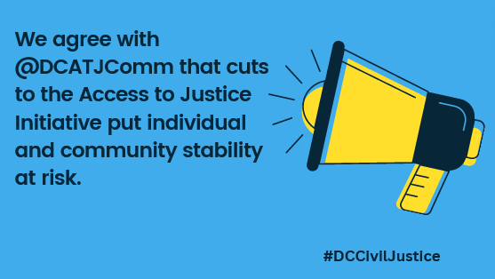

Our organization needs stable Access to Initiative funding to be able to serve our clients and preserve stable communities. #DCCivilJustice @councilofdc @cmbrookepinto @chmnmendelson
[Use your own logo, etc.]
Group Tweet D.C. Council: @chmnmendelson @anitabondsdc @CM_McDuffie @robertwhite_dc @CMCHenderson @brianneknadeau @CMBrookePinto @CMFrumin @CMLewisGeorgeW4 @CMZParker5 @charlesallen @vincegrayward7 @trayonwhite

Sample E-Mail (from ED/Board)

Councilmember [CM name] or Councilmembers [if group e-mail]:

As you enter these final weeks of the FY25 budget process, we ask you to prioritize the restoration of funding to the Access to Justice Initiative to $31.668M. While we are grateful that the Judiciary Committee (with the help of the Business & Economic Development and Health Committees) was able to partially restore funding, we are still left with a $18.9M or 60% gap from FY24 funding levels. Without level funding, we will be unable to continue supporting District residents facing life-changing legal needs.

- In practical terms, if we lose 60% of our Initiative funding, that translates to [insert data like ## staff members, ## clients served, #cases handled, programs you might end]
- The work that we do is critical to your constituents. [Describe your work]

As you consider the proposed FY25 budget, please keep the Access to Justice Initiative among your highest budget priorities. If you are considering revenue opportunities, please consider whether the Initiative might benefit from that additional support.

Sincerely,

[Executive Director and/or Board President]

Group E-Mail D.C. Council:

TO: pmendelson@dccouncil.gov; kmcduffie@dccouncil.gov; abonds@dccouncil.gov; rwhite@dccouncil.gov; chenderson@dccouncil.gov; bnadeau@dccouncil.gov; bpinto@dccouncil.gov; mfrumin@dccouncil.gov; jlewisgeorge@dccouncil.gov; zparker@dccouncil.gov; callen@dccouncil.gov; vgray@dccouncil.gov; twhite@dccouncil.gov

Group CC: bstum@dccouncil.gov; ecash@dccouncil.gov; dparks@dccouncil.gov; dcrawford@dccouncil.gov; jhudson@dccouncil.gov; afowlkes@dccouncil.gov; kwhitehouse@dccouncil.gov; mshaffer@dccouncil.gov; grogoff@dccouncil.gov; nrivero@dccouncil.gov; dmeni@dccouncil.gov; ghulick@dccouncil.gov; lgroft@dccouncil.gov; lcmiles@dccouncil.gov; khunt@dccouncil.gov; neasley@dccouncil.gov; rroberts@dccouncil.gov; kwiley@dccouncil.gov; kmitchell@dccouncil.gov; anunes@dccouncil.gov; sbunn@dccouncil.gov; tnorflis@dccouncil.gov; wlockridge@dccouncil.gov; sgales@dccouncil.gov; emarolf@dccouncil.gov; erodriguezlabrada@dccouncil.gov

Sample E-Mail (from Staff Member)

Councilmember [CM name]:

I am reaching about the proposed cuts to the Access to Justice Initiative. I am employed at [grantee organization]. Every day, I work to help low-income District residents who are struggling with difficult problems like [insert examples]. I see what a difference it makes for them to have a lawyer by their side. I also see how those without a lawyer fare without legal help.

IF APPLICABLE: I am also a resident of Ward [insert number]. I am worried that with this funding cut, important services will no longer be available to my neighbors in my Ward.

[Add any more detail or specific experiences.]

As you consider the proposed FY25 budget, please keep the Access to Justice Initiative among your highest budget priorities and support restoration to $31.668M, level to FY24 funding.

Thank you,

[Name and Address]

Sample E-Mail (from DC Resident)

Councilmember [CM name]:

I live in Ward [insert number]. I am reaching out about the Access to Justice Initiative and urge you to restore funding to $31.668M. I know that the Council has found some funding to address the proposed budget cuts to the program, but that there is still a $18.9M gap. I am worried that with this funding cut, important services will no longer be available to my neighbors in my Ward. I know that helping my neighbors deal with legal issues like eviction, family conflict, economic hardship, and other problems makes my community a more stable place to live.

[Add any more detail or specific experiences.]

I hope that you will prioritize the Access to Justice Initiative as the budget process continues. We need to keep these services available to District residents.

Thank you,

[Name and Address]

D.C. Councilmember and Committee Rosters available in PDF and MS Word

