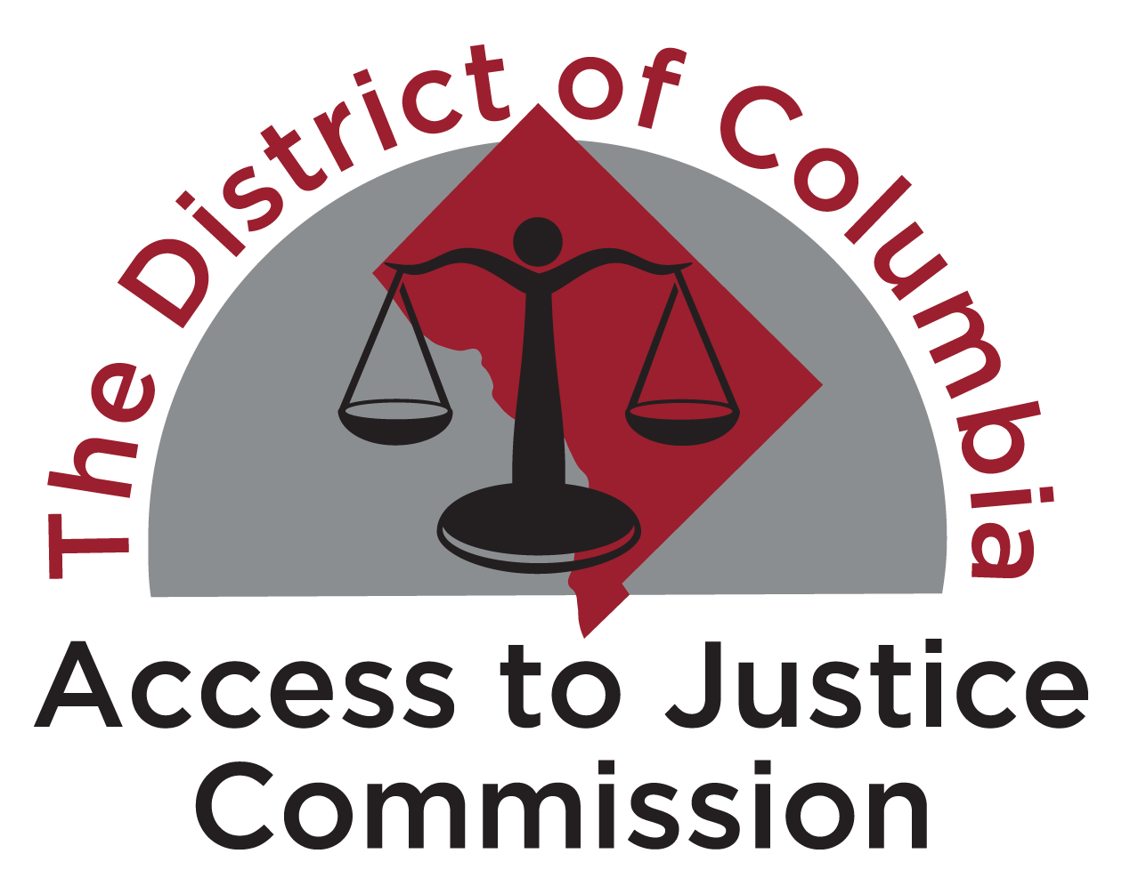

Raising the Bar in D.C. - A Funding Campaign for Legal Services

___________________________________________________________________________________

Law Firm Reporting Form - Donations in 2022
Reporting Deadline: March 15, 2023

Instructions
The D.C. Access to Justice Commission (“Commission”) is deeply grateful for your firm’s participation in the Raising the Bar in D.C. Campaign. For your firm to be formally recognized for its participation in 2022, the firm must submit the attached reporting form to Ernst & Young. This information will be kept confidential by Ernst & Young. Ernst & Young will only release the following information to the Commission:

- the recognition level (Platinum, Gold or Silver) for each participating firm;
- the aggregate amount of money donated by all participating firms to all eligible recipient organizations through this Campaign;
- the aggregate net change in the amount of money donated to all eligible recipient organizations through this Campaign.

Ernst & Young will not release any financial information about any individual firm. Only aggregated data will be released to the Commission.

When calculating the firm’s recognition level and completing the reporting form, please keep the following in mind:

- Only monetary donations, donations of attorney’s fees awarded in cases, and payments for Equal Justice Works or other fellowships sponsored by the firm at one of the eligible recipient organizations listed below count toward meeting the benchmark level. The value of pro bono work, the value of loaned associates, in-kind donations made by the firm, and donations made by individual attorneys do not count.

- Only donations to the eligible recipient organizations listed below count toward meeting the benchmark level. Firms may only count contributions to the D.C. Access to Justice Foundation (i.e., the Commission) once they have reached the Silver level through donations to one or more of the other listed organizations. In other words, donations to the Commission may only be counted to move a firm up a level – either from the Silver to the Gold level, or from the Gold to the Platinum level.

- D.C. office revenue should be calculated as an average of the previous three years’ revenues. For this year, revenue should be calculated as the average of D.C. office revenue for 2019, 2020 and 2021.

- Fellowship donations may be prorated over a five-year period. Please alert the Commission (margaret.emery@dcaccesstojustice.org) if the firm is electing to utilize this option.

Reporting Information

Please provide the total amount of monetary donations (this includes cash donations, donations of attorney’s fees, and payments for fellowships sponsored by the firm at one of the eligible recipient organizations) made by the firm to eligible recipient organizations in 2022:

$_____________________________

Please certify the benchmark level (Platinum, Gold or Silver) that this donation amount represents for the firm:

- Platinum (.11% of D.C. office revenue)
- Gold (.09% of D.C. office revenue)
- Silver (.075% of D.C. office revenue)

If the firm increased or decreased its giving to eligible recipient organizations between 2021 and 2022, please provide the aggregate net increase or decrease in giving. This will permit the Commission to quantify how much additional monetary support was generated through the 2022 Campaign:

$____________________________

Please check off the organizations to which the firm made monetary donations in 2022. In doing so the firm is confirming that only donations made to eligible recipient organizations were counted toward the benchmark level. Do not list individual amounts donated to each organization.

Eligible Recipient Organization | √
Advocates for Justice and Education
Amara Legal Center
Asian Pacific American Legal Resource Center
Ayuda
Bread for the City Legal Services
CAIR Coalition
CARECEN
Catholic Charities Immigration Legal Services
Catholic Charities Legal Network
Children’s Law Center
Christian Legal Aid of D.C.
D.C. Access to Justice Foundation (only count donations in total if your firm has reached at least the Silver level without them)
D.C. Affordable Law Firm
D.C. Bar Foundation
D.C. Bar Pro Bono Center
D.C. Crime Victims Resource Center
D.C. KinCare Alliance
D.C. Volunteer Lawyers Project
DV LEAP
First Shift Justice Project
Human Rights First – D.C. Asylum Legal Representation Project
Kids in Need of Defense (KIND) – D.C. Office
Legal Aid Society of the District of Columbia
Legal Counsel for the Elderly
Mid-Atlantic Innocence Project
Mil Mujeres Legal Services
Neighborhood Legal Services Program
NVRDC – Network for Victim Recovery D.C.
Open City Advocates
Quality Trust for Individuals with Disabilities
Rising for Justice
School Justice Project
Tahirih Justice Center
Tzedek D.C.
U.D.C. Summer Law Public Interest Fellowships
University Legal Services
Washington Area Lawyers for the Arts
Washington Lawyers Committee for Civil Rights & Urban Affairs
Washington Legal Clinic for the Homeless
Whitman-Walker Legal Services

___________________________________
Law Firm Name (please list name as you'd like it to appear in campaign listings and materials)

____________________________________
Name of Individual Completing Form

____________________________________
Title

____________________________________
Signature

____________________________________
Address 1

____________________________________
Address 2

____________________________________
City, State, Zip

____________________________________
Phone Number

____________________________________
Email

Signed forms should be submitted via e-mail by March 15, 2023 to:

Vesna Vidovic
Ernst & Young
vesna.vidovic@ey.com

Please address any questions about completion of this form or about the Campaign to Margaret Emery at margaret.emery@dcaccesstojustice.org.

