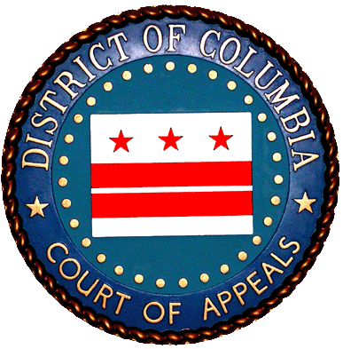 

June 5, 2013

For Immediate Release For more information, contact: Leah Gurowitz, 202-879-1700 (DC Courts)

Jess Rosenbaum, 202.352.5032 (D.C. Access to Justice Commission)

Mark Herzog, 202-626-1306 (D.C. Bar Pro Bono Program)

**D.C. Courts Chief Judges Publish 2nd Annual Capital Pro Bono Honor Roll**

**-** Significant number of attorneys volunteering services **-**

The chief judges of the DC Court of Appeals and the DC Superior Court just released their second annual *Capital Pro Bono Honor Roll,* recognizing the contributions of those D.C. Bar members and others authorized to perform pro bono legal work who donated 50 hours or more of pro bono service during the last calendar year.

Almost 4100 attorneys reported performing 50 hours or more of pro bono work in 2012, the 2nd year for which data was gathered. Even more impressive, more than half (over 2400) of them reported performing 100 hours or more of pro bono work in 2012, qualifying them for inclusion in the *High Honor Roll*. Despite greater pressures to bill more hours, work more efficiently, and use fewer resources, this year’s Honor Roll represents an increase of almost 20% over last year’s inaugural Honor Roll. “The Honor Roll includes lawyers at all levels of experience, from our newest to our most senior attorneys, and in a wide variety of practice settings, from solo and small firm practice, to government lawyers, to big firm practitioners,” said James Sandman, chair of the D.C. Bar Pro Bono Program. “The breadth of pro bono involvement is powerful evidence of the strong pro bono culture of DC’s legal community.”

In a joint letter published today, DC Court of Appeals Chief Judge Eric T. Washington and Superior Court Chief Judge Lee F. Satterfield wrote, “We are so pleased and proud to congratulate the more than 4000 members of the 2012 Capital Pro Bono Honor Roll for their remarkable pro bono service to our neighbors in need. Through their tireless work, an elderly couple avoided homelessness; a survivor of domestic violence finally confronted her abuser in court; a tenant association purchased the building where most of its members have lived all their lives; a recently discharged veteran received his rightful benefits; a seriously ill man has now been approved by his insurance company to receive a lung transplant; and so many other individuals, families, non-profits and small, disadvantaged businesses received critical access to counsel who helped lift them to a better place.”

Honor Roll members reflect the full diversity of our legal community, hailing from 133 law firms and scores of solo practices, federal government agencies, and public interest organizations. “We are delighted to see this robust pro bono service from across the D.C. legal community,” said Peter Edelman, chair of the D.C. Access to Justice Commission. “At a time when many lawyers and law firms are continuing to experience economic pressures, it is deeply gratifying to see such a sharp rise in Honor Roll participation. It is a powerful statement of the dedication of our legal community to access to justice.”

In addition to receiving praise by the court, all Honor Roll members satisfy their professional obligation under Rule 6.1 of the D.C. Rules of Professional Conduct by performing 50 hours or more of pro bono service.

The Capital Pro Bono Honor Roll and chief judges’ joint letter are available on the courts’ website.

# # #